**Prototype 01 — SMA & Gesture with ML**

Shape Memory Alloy(SMA) or the muscle wire, which has the performance can “remember” its pre-deformed shape via thermal energy. The type I used in here which consists of 50% titanium and 50% Nickle. It has been used in so many different domains including robotics, optometry, aircraft, telecommunication and dentistry etc. I interested in the materiality of the shape memory material and the expressivity of the body movements. Both of them can be elaborated as its “performance”.

There is a philosophical word, hylozoism, which means all matter has life. How can I create a scene which is able to sdfsfsf inhabit both characteristfsfics and attributes to maximize the verisimilitude and liveness? I then tried to bridge the connection between deformation training methods of Shape Memory Material (SMM) and the machine learning algorithm (Neural Network) from hand gestures.

Comparing with the other actuators including motors, solenoid, electroactive polymer etc. used in multiple situations, for example hydraulic, pneumatic, magnetic or electrical demand, SMA is more “humanoid”. The heating transition from the martensite phase to the austenite phase is in a way more natural and quiet. Some aspects, training methods, the pseudo elasticity of the SMA made itself more compatible and flexible in the several areas. Also becoming costlier and limited in human interactive products and occasions.

To extend this thread, I was pondering the reason most people interested in the liveness of nonlife or the emergence of the life of nonlife. For example, Philip Beesley’s Radient Soil in 2003 compromised of plant-like architectural structures, in which plume-like structures reacted according to surrounding movements. It reminded me of carnivorous plants, representing a mesmerizing humanoid habit while “preying”. This can be regarded as underlying the analogy or the manifestation of the combination of synthetic and emotions.

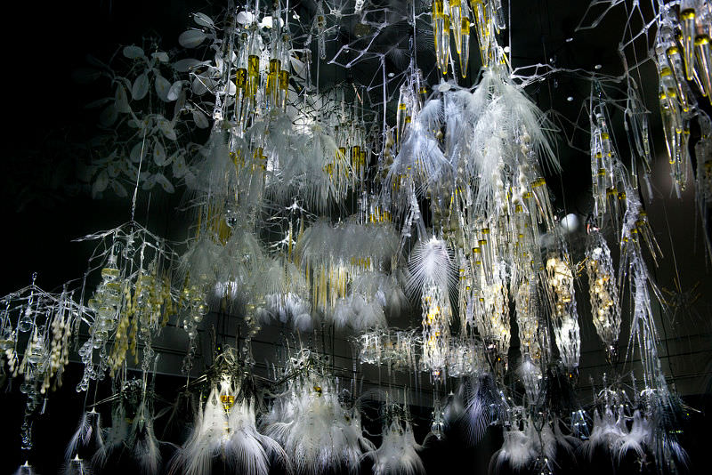

What also impressed me was Silk Pavilion, exploring the relationship between digital and biological fabrication in design made by Neri Oxman in 2013 from MIT media lab. This work combined two worldviews together, one spins silk by the robotic arms, the other fills in the gaps. Non-liveness and liveness collaborate to build the product. As Neri said, “if the final frontier of design is to breathe like into products and the buildings around us to form a two-material ecology, then the designers must unite these two worldviews.”

